**Understanding AI, Machine Learning, and Deep Learning**

**Overview**

This guide will help you understand the relationships and distinctions between **Artificial Intelligence (AI)**, **Machine Learning (ML)**, and **Deep Learning (DL)**.

**Key Concepts**

**1. Artificial Intelligence (AI)**

* **Definition**: AI is a branch of computer science focused on creating intelligent machines that can perform tasks that typically require human intelligence. This includes decision-making, problem-solving, and understanding natural language.
* **Examples of Intelligent Machines**:
  + **Autonomous Cars**: Such as Tesla, which can drive without human input.
  + **Virtual Assistants**: Like Google Assistant, which interacts in a human-like manner.

**2. Machine Learning (ML)**

* **Definition**: ML is a subset of AI that enables machines to learn from data without being explicitly programmed. It focuses on developing algorithms that can identify patterns and make decisions based on data.
* **Example**:
  + A system designed to differentiate between images of Iron Man and Captain America would be trained using numerous labeled images. The algorithm learns to recognize patterns and can then classify new images 2.

**3. Deep Learning (DL)**

* **Definition**: DL is a further subset of ML that uses artificial neural networks (ANNs) to analyse various factors of data. These networks are inspired by the human brain's structure and function.

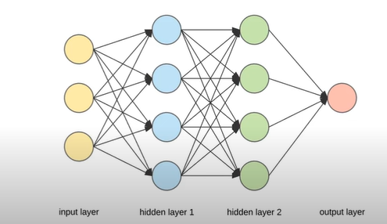

* **Structure of ANNs**:
  + **Input Layer**: Receives the input data.
  + **Hidden Layers**: Process the data through interconnected neurons.
  + **Output Layer**: Produces the final output 3.

**Relationship Between AI, ML, and DL**

* **Venn Diagram Representation**:

* + **AI** is the broadest field encompassing all intelligent systems.
  + **ML** is a subset of AI focused on data-driven learning.
  + **DL** is a specialized subset of ML that utilizes neural networks for complex data processing 4.

**Summary Table**

|  |  |  |
| --- | --- | --- |
| **Term** | **Definition** | **Examples** |
| Artificial Intelligence | Creating intelligent machines | Autonomous cars, Google Assistant |
| Machine Learning | Algorithms that learn from data | Image recognition systems |
| Deep Learning | Neural networks for data analysis | Image and speech recognition |

**Important Notes**

* Understanding the distinctions between these terms is crucial for grasping the broader concepts in technology and data science.
* AI is not synonymous with ML or DL; they represent a hierarchy of concepts where each term builds upon the previous one.

**Questions to Consider**

* What are the key differences between AI, ML, and DL?
* Can you provide examples of each type of technology?
* How does deep learning improve upon traditional machine learning techniques?